Excel Assignment - 17

1. What are modules in VBA and describe in detail the importance of creating a module?

Answer :

VBA module is a “.bcf” extension file that holds the code in the [visual basic editor](https://excelchamps.com/vba/visual-basic-editor/). Each module has its own code window where you can write. You can insert a new module, delete, backup, and import it. In simple words, it’s like a text file that you open in the notepad.

In this tutorial, we will learn all about using a module in VBA.

Insert a VBA Module

1. First of all, open the Project Window if it’s not there already.
2. Next, right-click on the project ([Excel File](https://excelchamps.com/vba/objects/workbook/)) in which you want to insert a module.
3. After that, go to the Insert and click on the “Module”.
4. Once you do that, you will instantly get a new module and can open its code window to write the code.

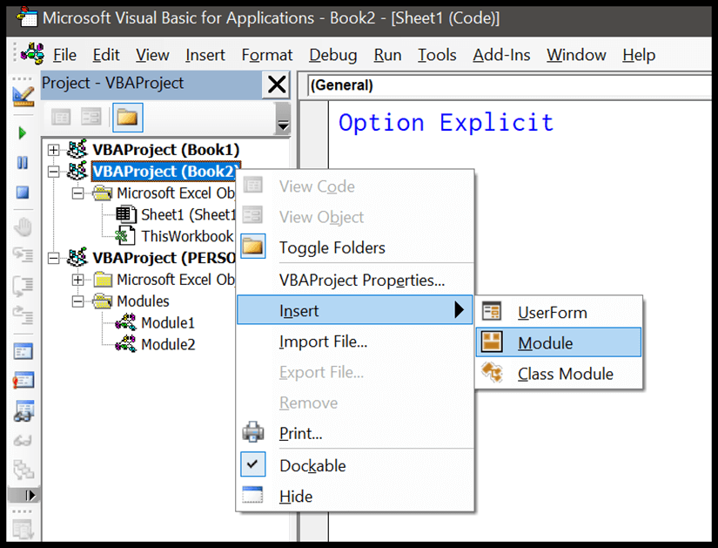

You can also go to the insert menu and then the module to insert it.

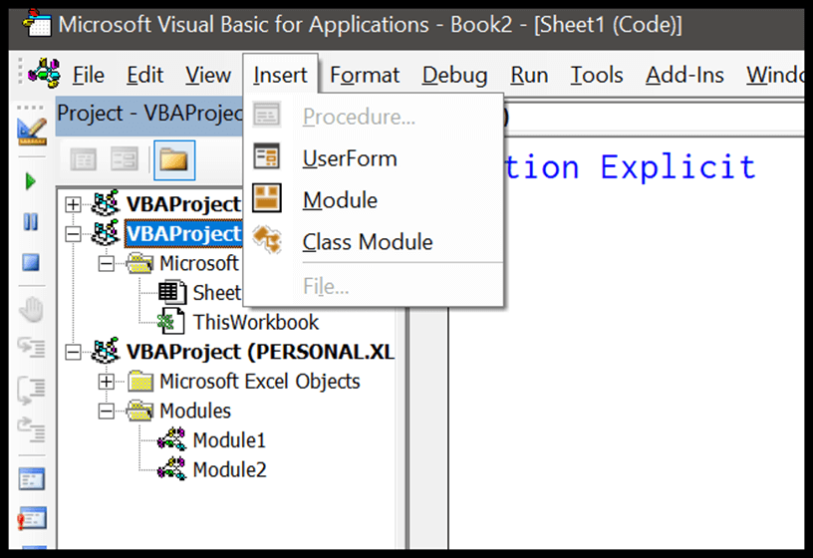

When you insert a new module, VBA creates a separate folder for all the modules that you have in the project.

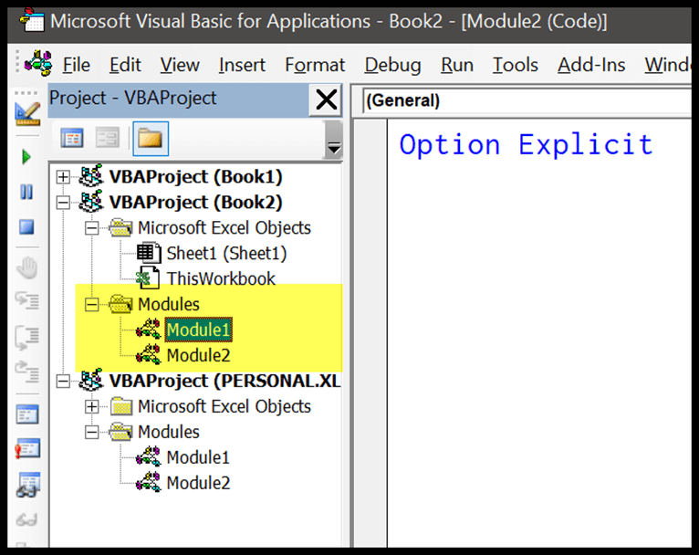

Delete a VBA Module

1. Click on the project from which you want to delete a module.
2. Now right-click on the module that you want to delete and click “Remove”.
3. After that, you need to confirm if you wish to back up the module before deleting it.
4. In the end, click on “Yes” to delete it.

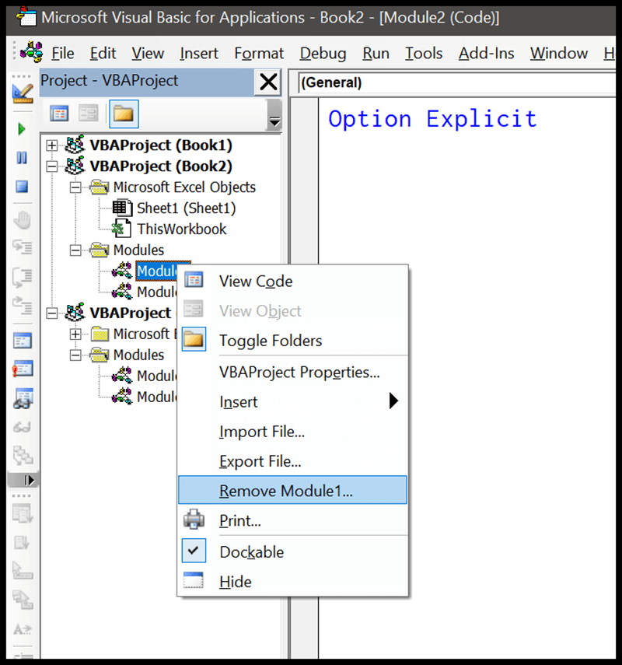

There’s one thing that you need to know here when you click on the remove option, it asks you to back up your module before removing it (if you want).

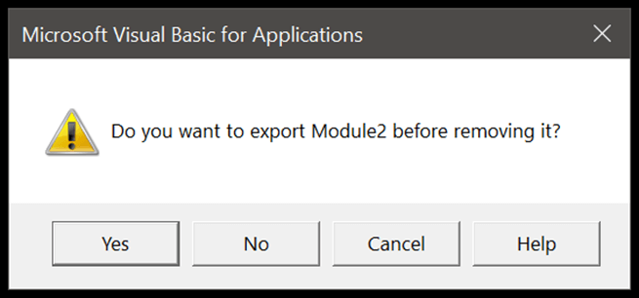

It’s a smart way to remind you to get the backup of the module.

Export and Import a VBA Module

You can also import and export a module from one Excel file to another instead of copy-pasting the codes. This is one of the best ways to share your codes with others. When you right-click on a module you have both options there.

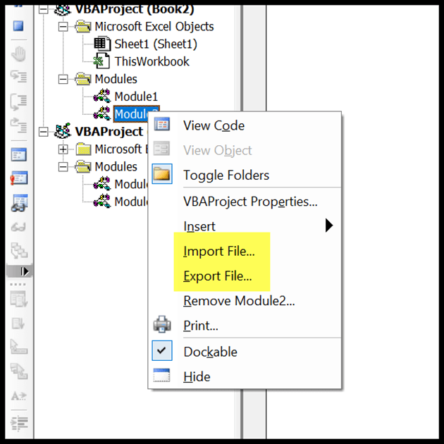

1. What is Class Module and what is the difference between a Class Module and a Module?

Answer :

A class module is a group of code that allows you to create objects and utililise them in your application

Modules are collections of methods and constants. They cannot generate instances. Classes may generate instances (objects), and have per-instance state (instance variables).

-------------------------------------------------------------------------------------------------------------------------------

1. What are Procedures? What is a Function Procedure and a Property Procedure?

Answer :

A procedure is a block of Visual Basic statements enclosed by a declaration statement ( Function , Sub , Operator , Get , Set ) and a matching End declaration. All executable statements in Visual Basic must be within some procedure.

A Function procedure is a series of Visual Basic statements enclosed by the Function and End Function statements. The Function procedure performs a task and then returns control to the calling code. When it returns control, it also returns a value to the calling code.

A property procedure is a series of Visual Basic statements that allow a programmer to create and manipulate custom properties. Property procedures can be used to create read-only properties for forms, standard modules, and class modules

-------------------------------------------------------------------------------------------------------------------------------

1. What is a sub procedure and what are all the parts of a sub procedure and when are they used?

Answer :

A Sub procedure is a series of Visual Basic statements enclosed by the Sub and End Sub statements that performs actions but doesn't return a value. A Sub procedure can take arguments, such as constants, variables, or expressions that are passed by a calling procedure

A sub procedure is usually used to accept input from the user, display information, print information, manipulate properties or perform some other tasks. It is a program code by itself and it is not an event procedure because it is not associated with a runtime procedure.

Types of Procedures

* Transform procedures.
* Source procedures.
* Target procedures.

1. How do you add comments in a VBA code? How do you add multiple lines of comments in a VBA code?

Answer:

To add a comment in VBA, simply add an apostrophe sign before the line that you want to be marked as a comment.

select all the lines and then use the comment button from the toolbar or you can also add an APOSTROPHE at the starting of each line.

-------------------------------------------------------------------------------------------------------------------------------